**Assignment - SQL Concepts & Fundamentals**

**1 -** create database student

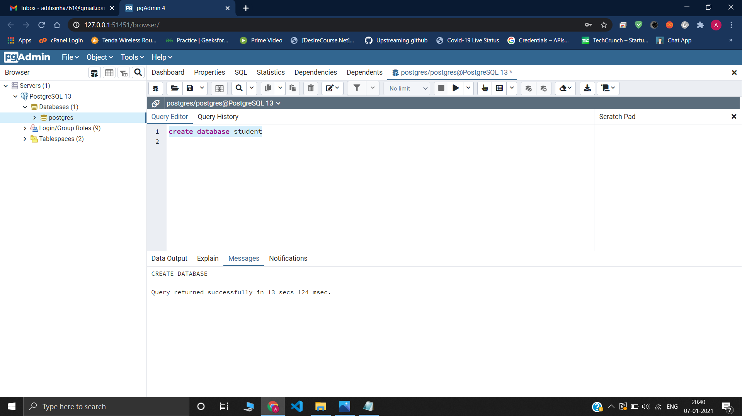

**2 – i)** create table StudentBasicInformation

(

StudentName varchar(20),

StudentSurname varchar(20),

StudentRollNo int,

StudentId int,

StudentCourse varchar(20),

StudentBranch varchar(20),

StudentCity varchar(20)

)

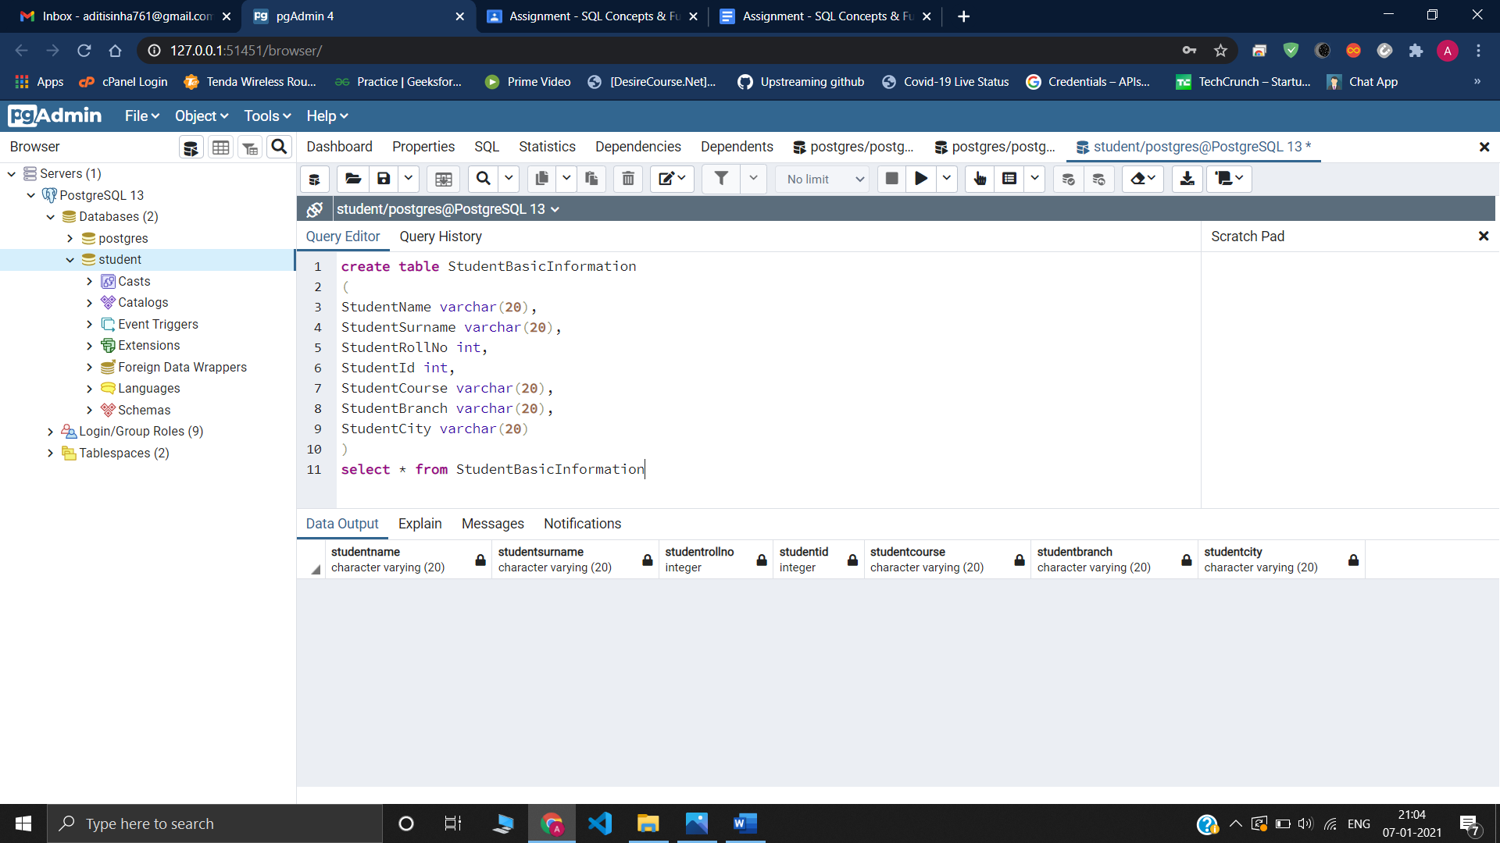

**ii)** create table StudentAdmissionPayment

(

StudentRollNo int,

StudentName varchar(20),

StudentId int,

AmountPaid float,

AmountBalance float,

TotalAmount float,

StudentCourse varchar(20)

)

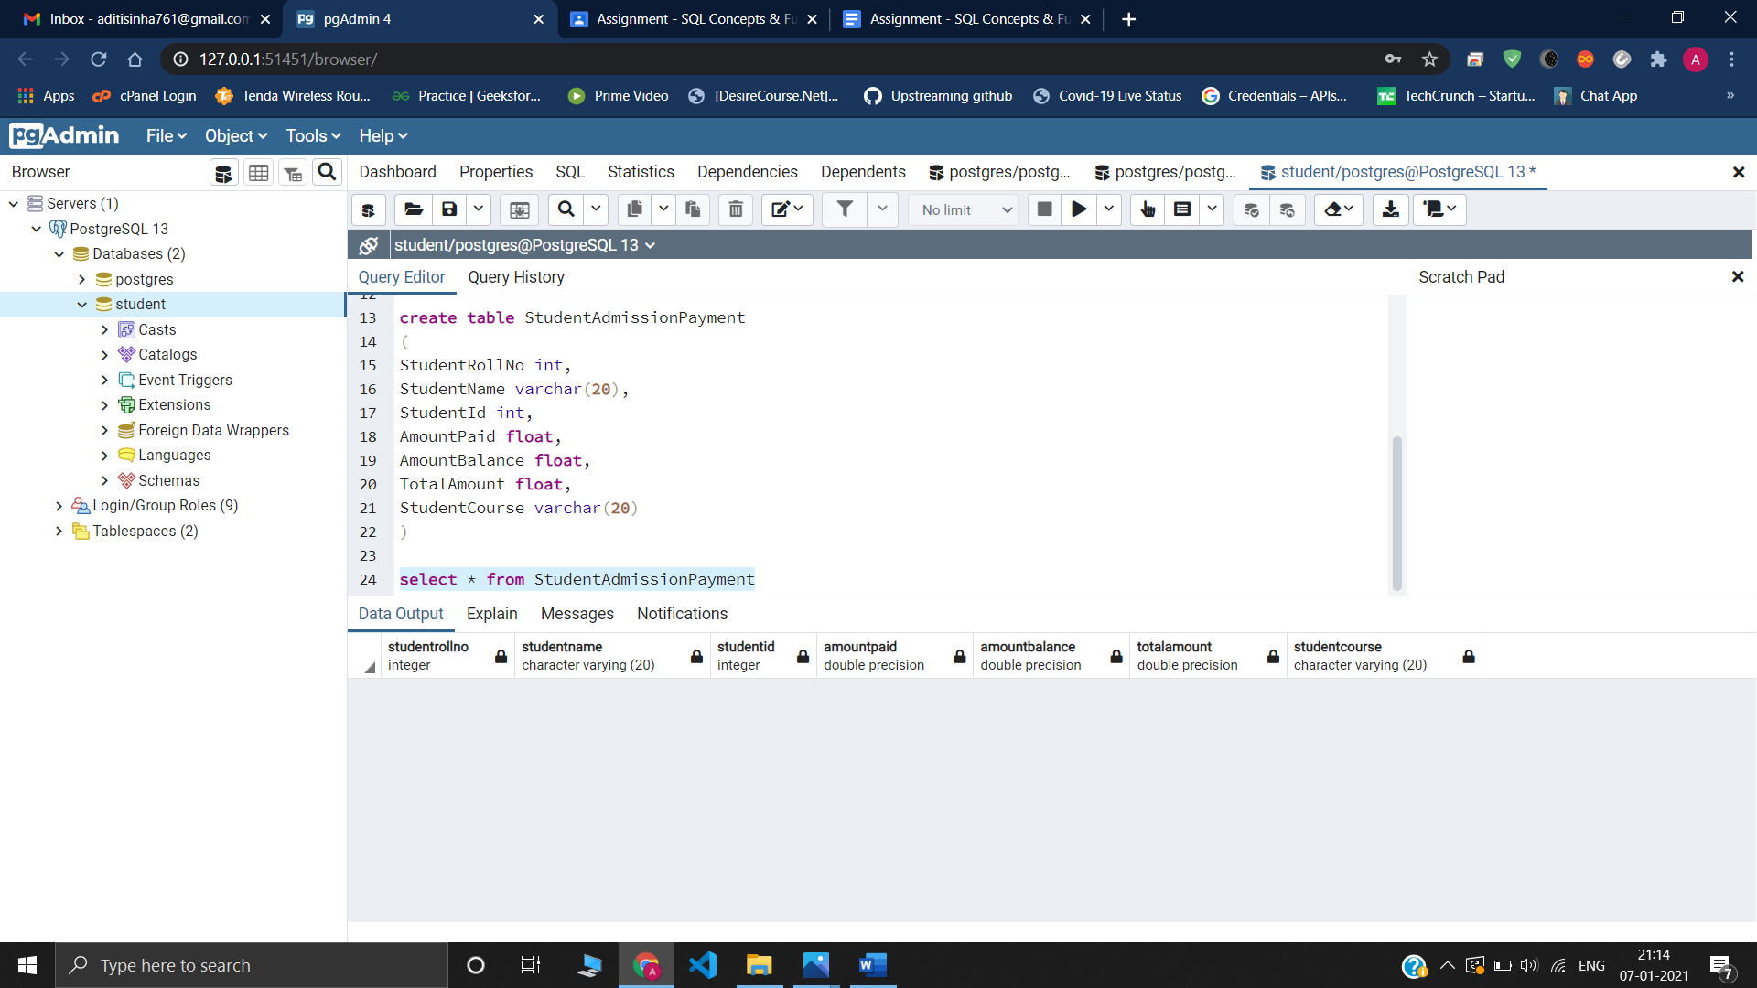

**iii)** create table StudentSubjectInformation

( SubjectOpted varchar(20),

StudentRollNo int,

StudentName varchar(20),

SubjectTotalMarks float,

SubjectObtainedMarks float,

StudentMarksPercentage float

)

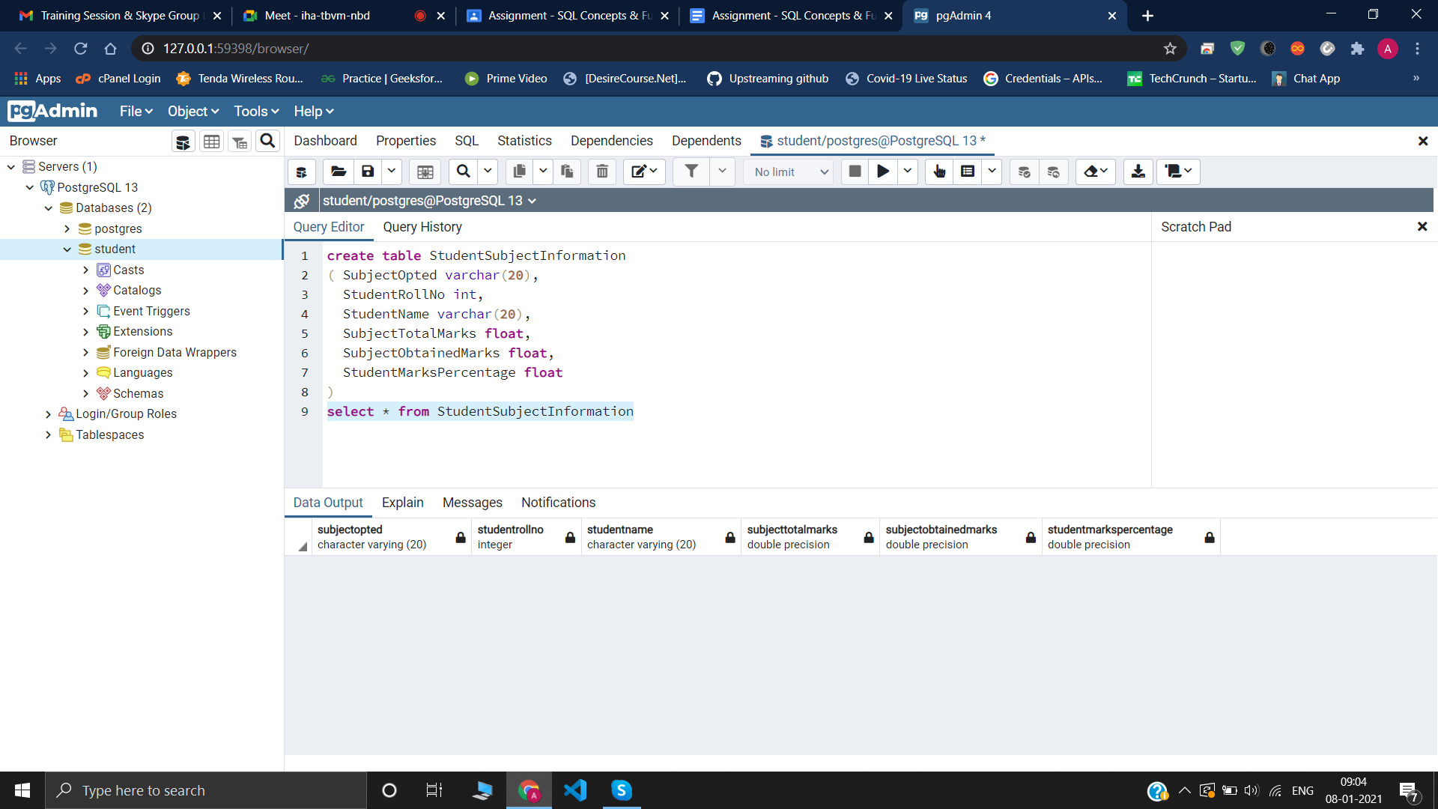

**iv)** create table SubjectScholarshipInformation

( StudentRollNo int,

StudentName varchar(20),

ScholarshipOpted varchar(20),

ScholarshipGet varchar(20),

ScholarshipName varchar(50),

ScholarshipAmount float,

ScholarshipCategory varchar(20)

)

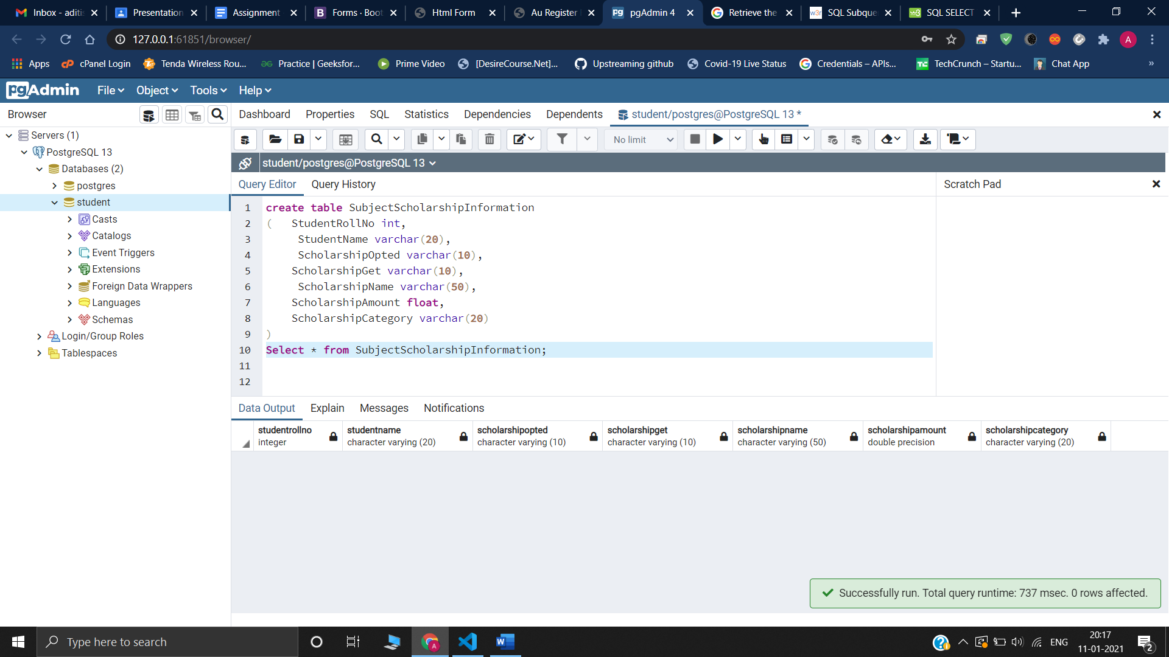

**3 –**

**i)**

insert into StudentBasicInformation values ('Adi','Sinha',1,101,'btech','cse','ghaziabad');

insert into StudentBasicInformation values ('Saksham','kashyap',2,102,'btech','cse','japiur');

insert into StudentBasicInformation values ('Anu','verma',3,103,'btech','IT','delhi');

insert into StudentBasicInformation values ('Aditya','Sinha',4,104,'bba','marketing','ghaziabad');

insert into StudentBasicInformation values ('Arjun','Sinha',5,105,'bsc','cs','ghaziabad');

insert into StudentBasicInformation values ('Dev','Singh',6,106,'bba','digital marketing','jaipur');

insert into StudentBasicInformation values ('Arun','Sharma',7,107,'btech','electrical','mumbai');

insert into StudentBasicInformation values ('vishal','roy',8,108,'bsc','electronics','delhi');

insert into StudentBasicInformation values ('Ayush','verma',9,109,'btech','ece','ghaziabad');

insert into StudentBasicInformation values ('shivam','rawat',10,110,'btech','ME','haryana');

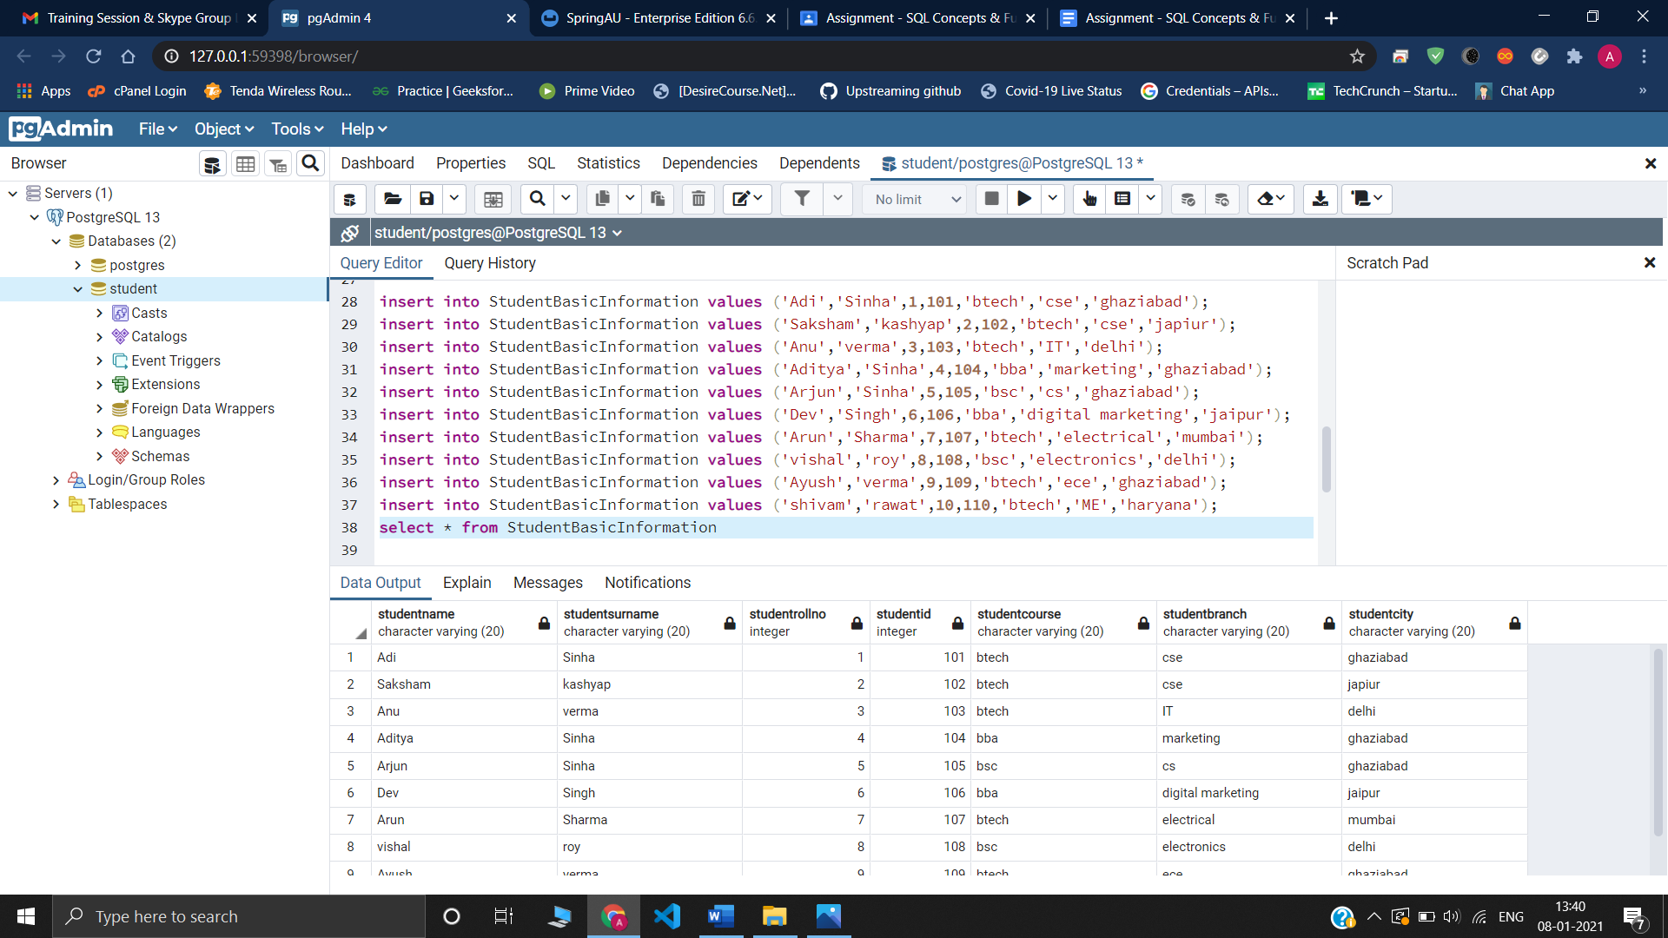

**ii)**

insert into StudentAdmissionPayment values (1,'Adi',101,50000,70000,120000,'btech');

insert into StudentAdmissionPayment values (2,'Saksham',102,60000,70000,130000,'btech');

insert into StudentAdmissionPayment values (3,'Anu',103,50000,90000,140000,'btech');

insert into StudentAdmissionPayment values (4,'Aditya',104,50000,70000,120000,'bba');

insert into StudentAdmissionPayment values (5,'Arjun',105,70000,70000,140000,'bsc');

insert into StudentAdmissionPayment values (6,'Dev',106,60000,40000,100000,'bba');

insert into StudentAdmissionPayment values (7,'Arun',107,60000,70000,130000,'btech');

insert into StudentAdmissionPayment values (8,'vishal',108,50000,90000,140000,'bsc');

insert into StudentAdmissionPayment values (9,'Ayush',109,90000,70000,160000,'btech');

insert into StudentAdmissionPayment values (10,'shivam',110,50000,70000,120000,'btech');

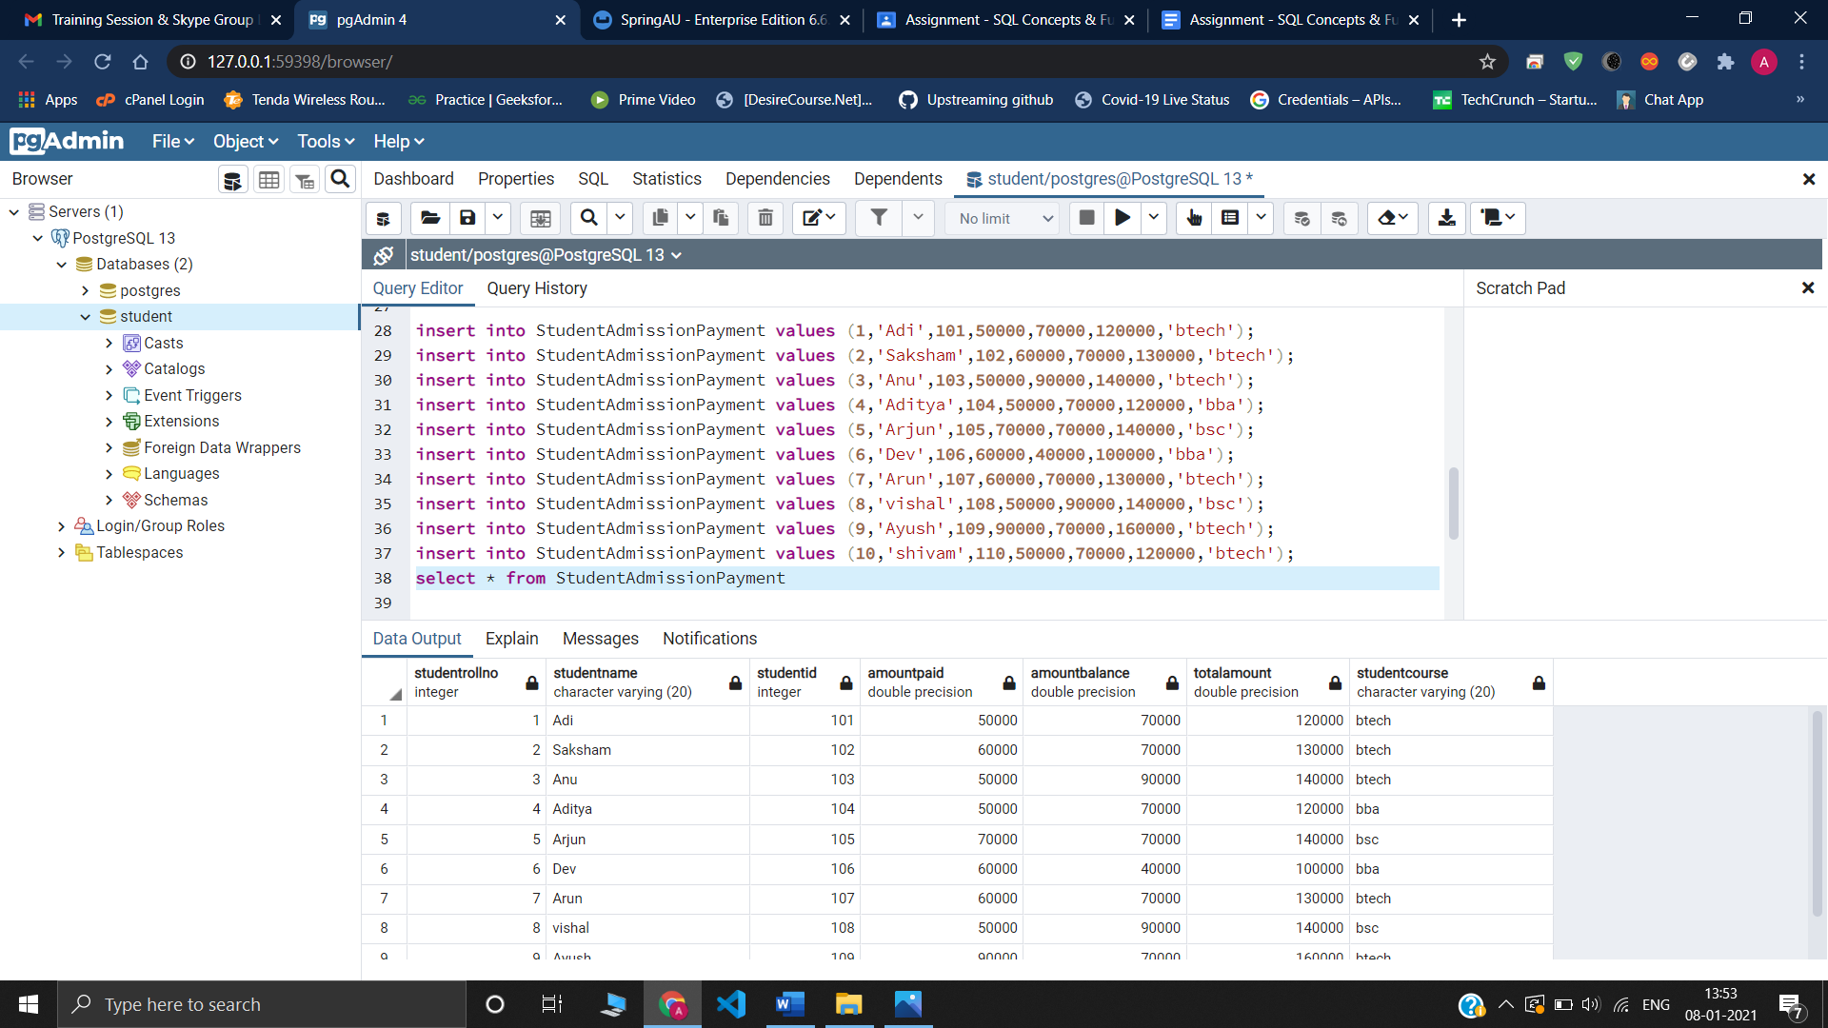

**iii)**

insert into StudentSubjectInformation values ('computer',1,'Adi',100,50,50);

insert into StudentSubjectInformation values ('computer',2,'Saksham',100,60,60);

insert into StudentSubjectInformation values ('IT',3,'Anu',100,50,50);

insert into StudentSubjectInformation values ('marketing',4,'Aditya',100,50,50);

insert into StudentSubjectInformation values ('computer',5,'Arjun',100,70,7);

insert into StudentSubjectInformation values ('digital marketing',6,'Dev',100,60,60);

insert into StudentSubjectInformation values ('electrical',7,'Arun',100,60,60);

insert into StudentSubjectInformation values ('electronics',8,'vishal',100,50,50);

insert into StudentSubjectInformation values ('ece',9,'Ayush',100,90,90);

insert into StudentSubjectInformation values ('ME',10,'shivam',100,50,50);

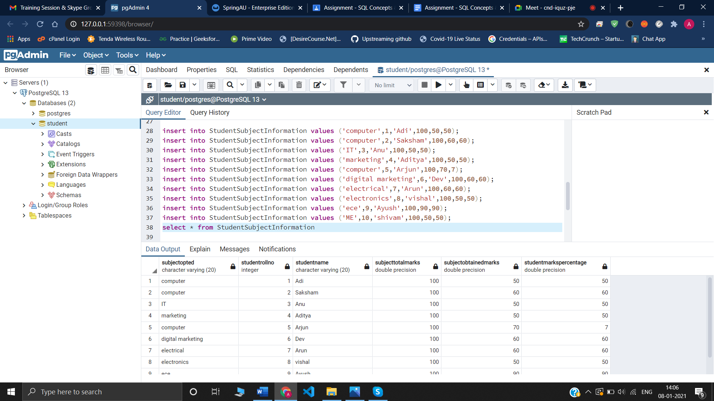

**iv)**

insert into SubjectScholarshipInformation values (1,'Adi','Yess','Noo','excellence',5000,'first');

insert into SubjectScholarshipInformation values (2,'Saksham','Yess','Yess','excellence',6000,'first');

insert into SubjectScholarshipInformation values (3,'Anu','Yess','Noo','excellence',4000,'first');

insert into SubjectScholarshipInformation values (4,'Aditya','Yess','Yess','excellence',5000,'first');

insert into SubjectScholarshipInformation values (5,'Arjun','Yess','Yess','excellence',7000,'first');

insert into SubjectScholarshipInformation values (6,'Dev','Yess','Yess','excellence',8000,'first');

insert into SubjectScholarshipInformation values (7,'Arun','Yess’,'Yess','excellence',6000,'first');

insert into SubjectScholarshipInformation values (8,'vishal','Yess','Noo','excellence',3000,'first');

insert into SubjectScholarshipInformation values (9,'Ayush','Yess','Yess','excellence',9000,'first');

insert into SubjectScholarshipInformation values (10,'shivam','Yess','Yess','excellence',5000,'first');

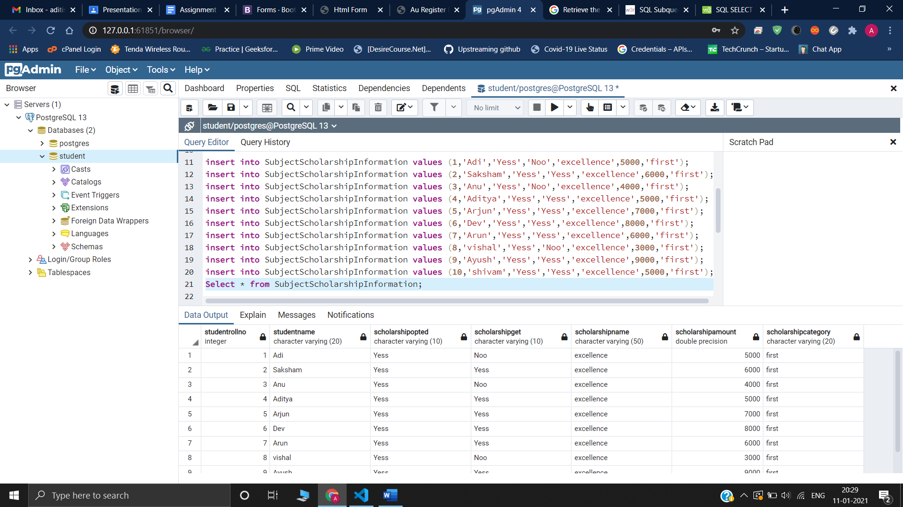

**5-** i) update StudentBasicInformation set StudentCity = 'delhi' where StudentName = 'Adi';

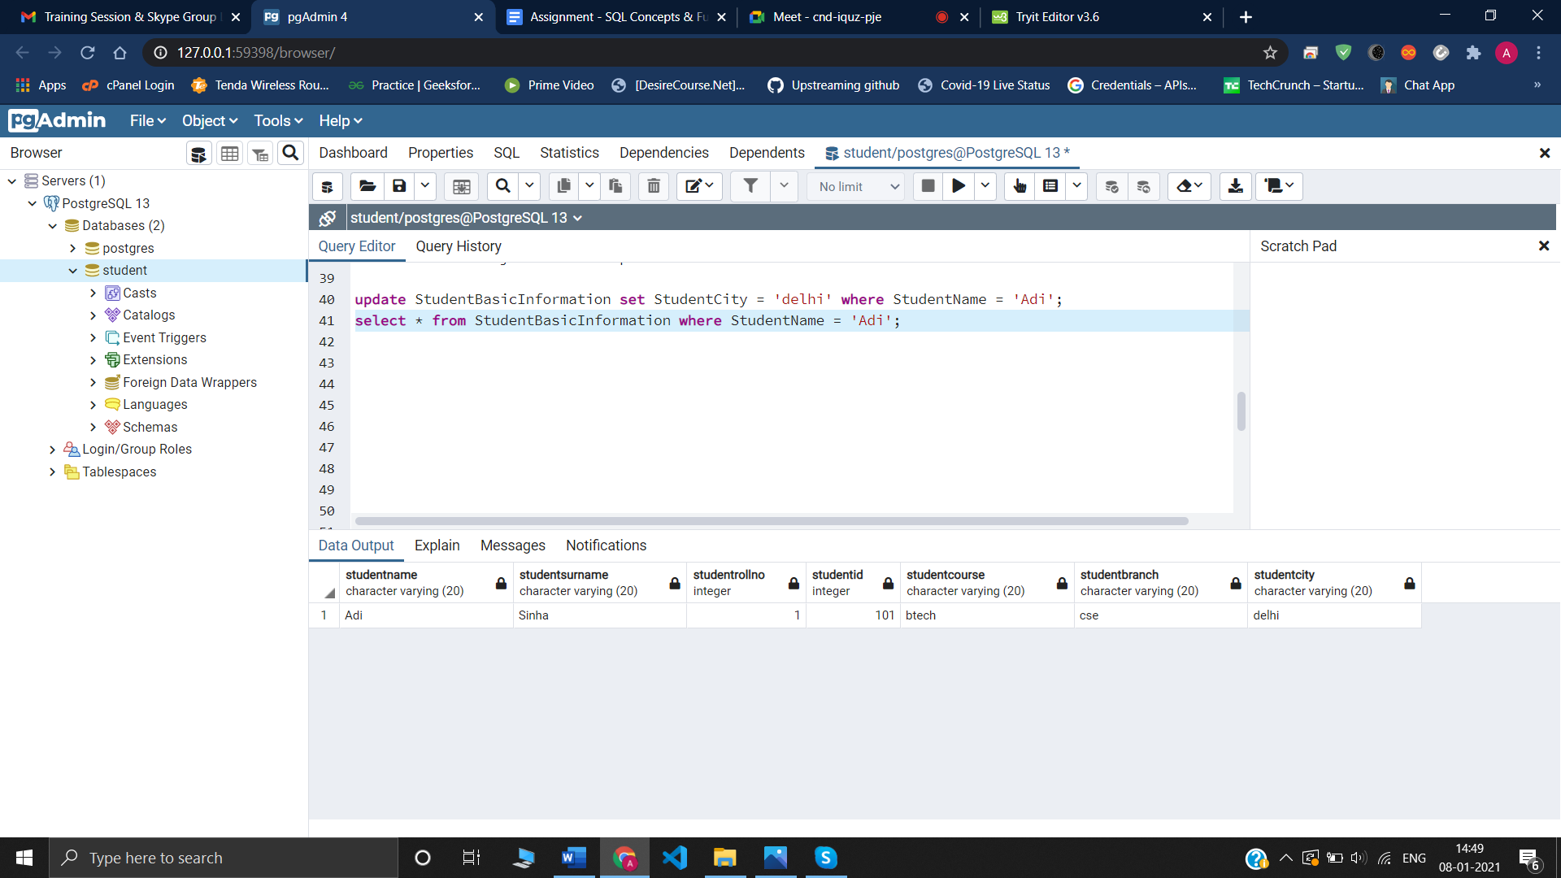

ii) update StudentBasicInformation set Studentbranch = 'ECE' where StudentName = 'Ayush';

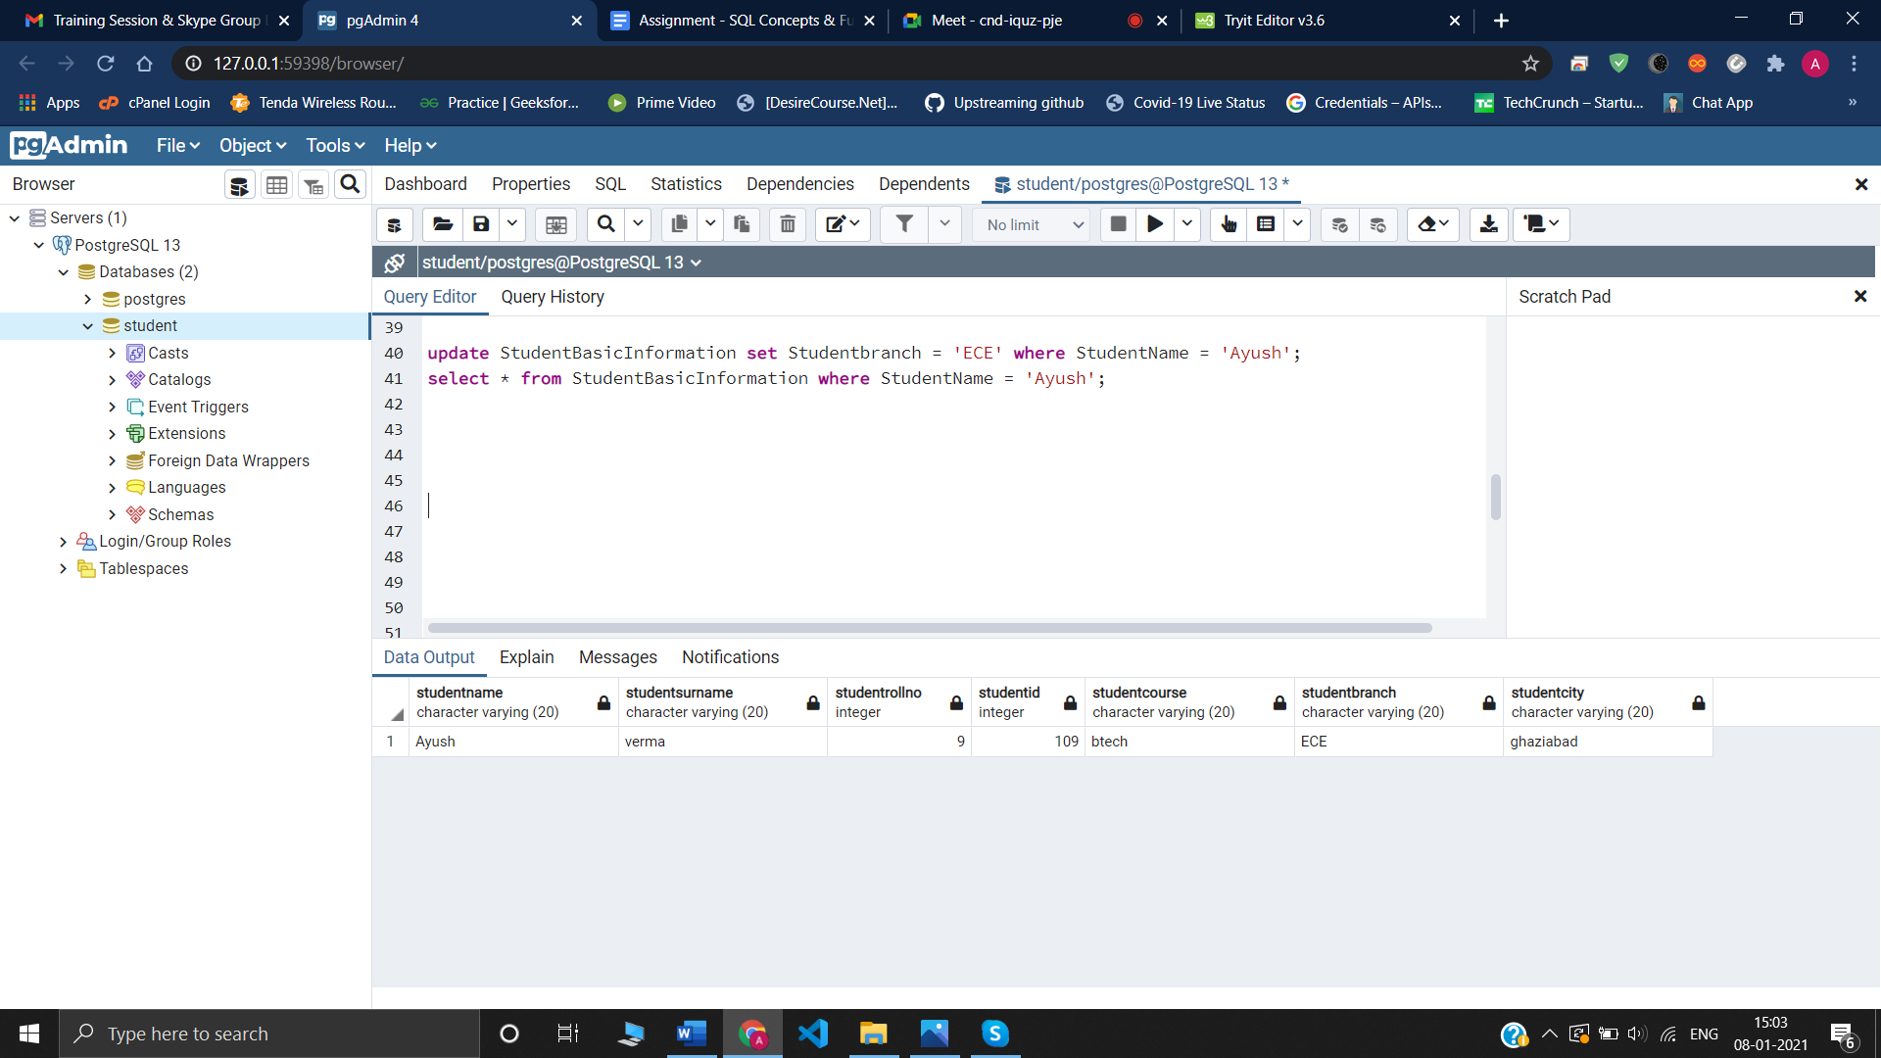

iii) update SubjectScholarshipInformation set ScholarshipAmount = 8000 where StudentName = 'Dev';

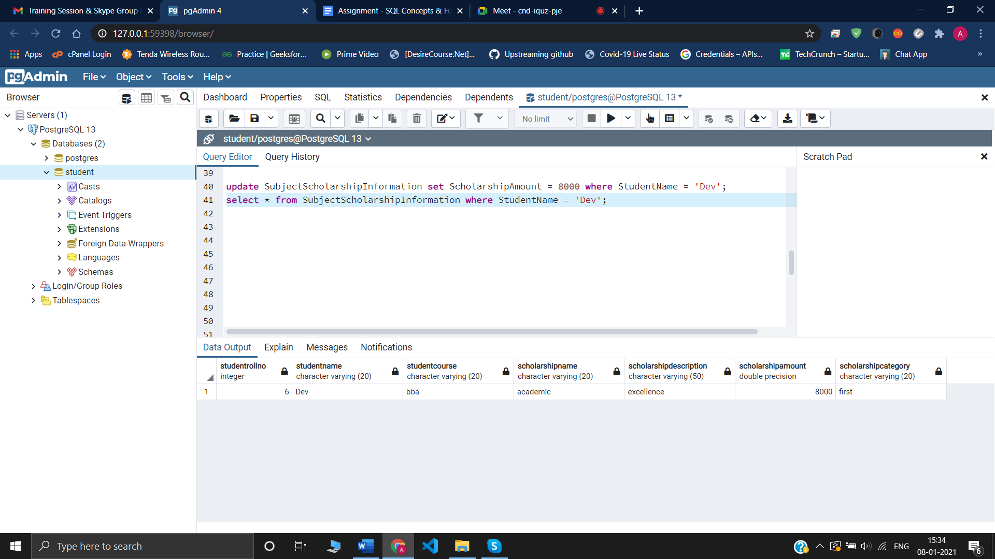

iv) update StudentSubjectInformation set StudentMarksPercentage = 70 where StudentName = 'Arjun';

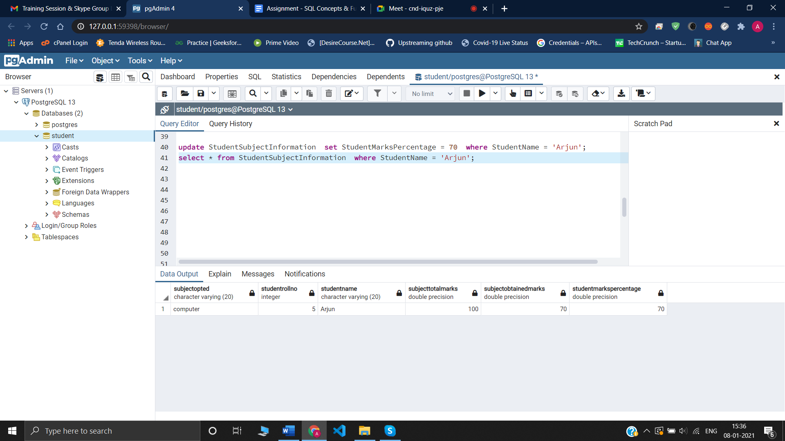

v) update SubjectScholarshipInformation set ScholarshipAmount = 8000 where StudentName = 'Adi';

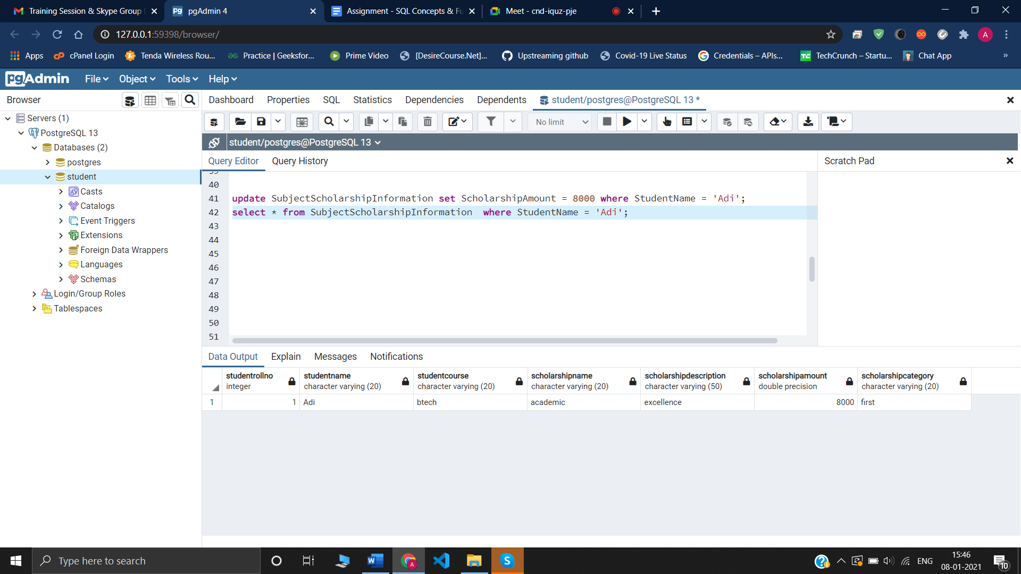

**7-**select * from SubjectScholarshipInformation where ScholarshipAmount >

5000;

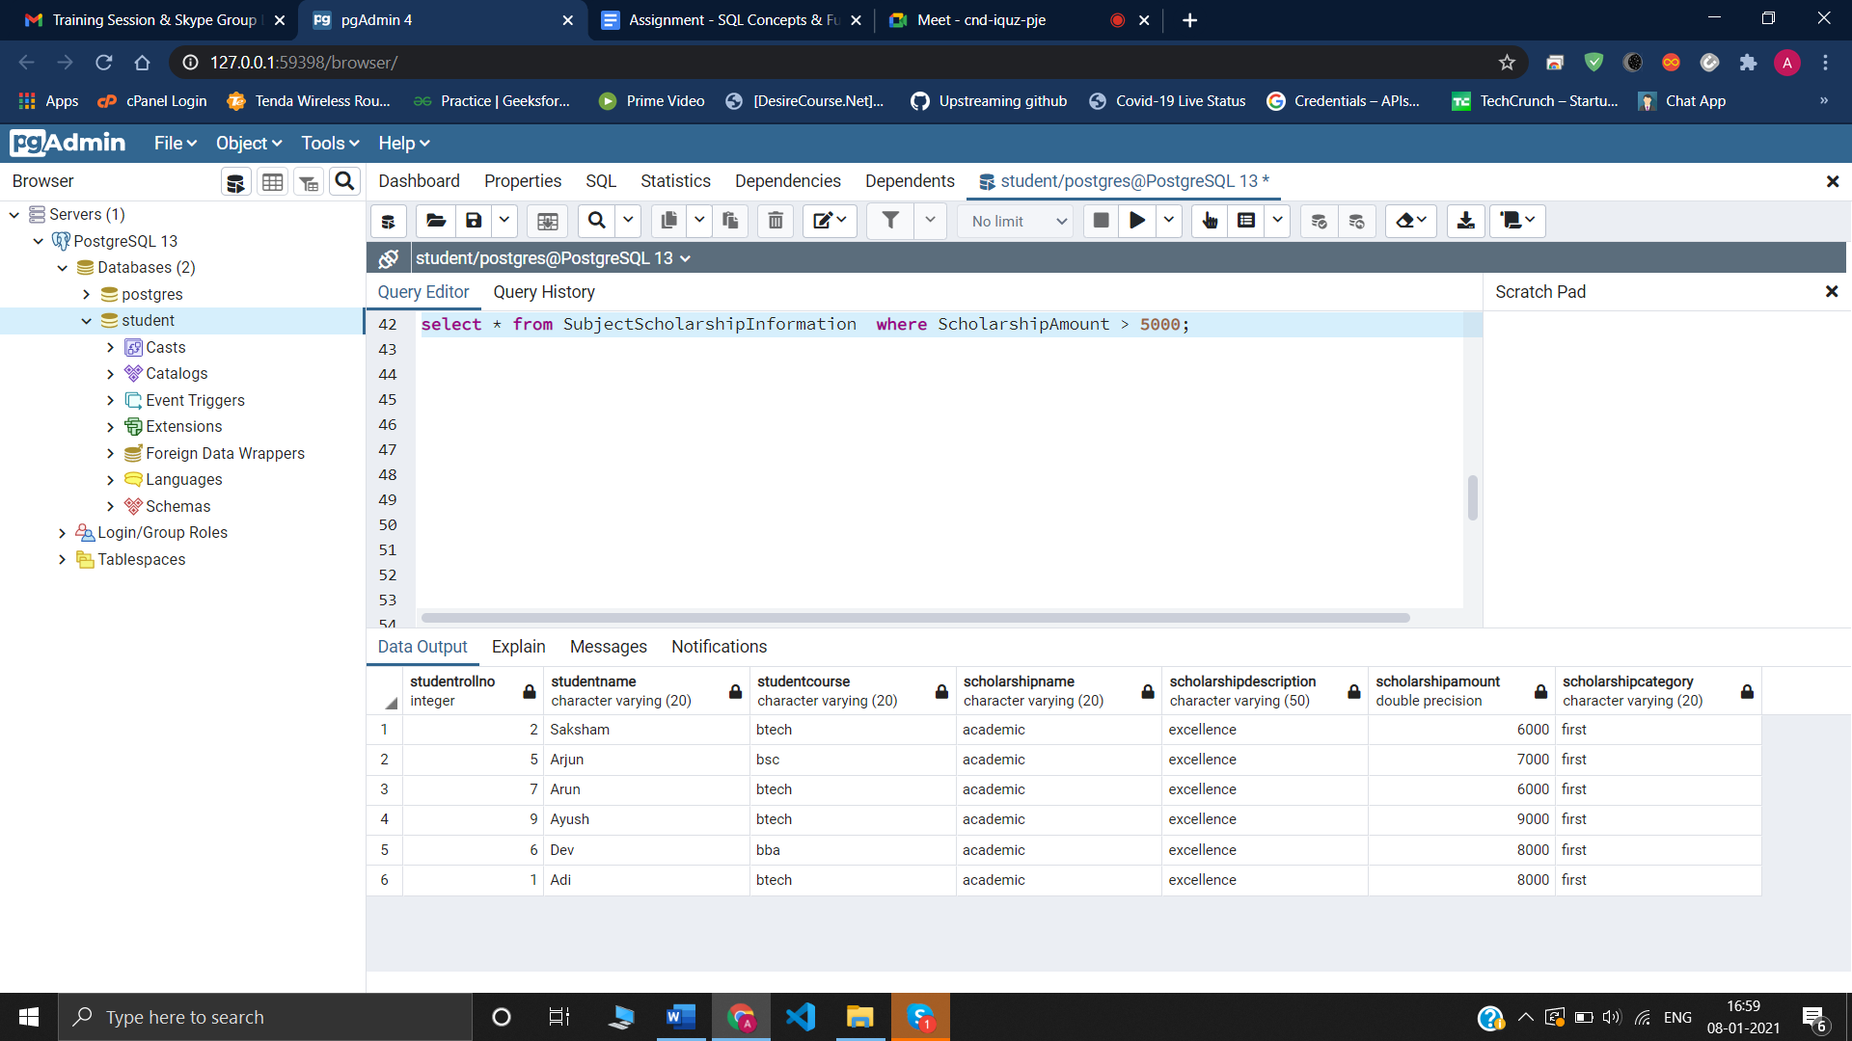

**8-**

Select * from SubjectScholarshipInformation where ScholarshipOpted = 'Yess' And ScholarshipGet = 'Noo';

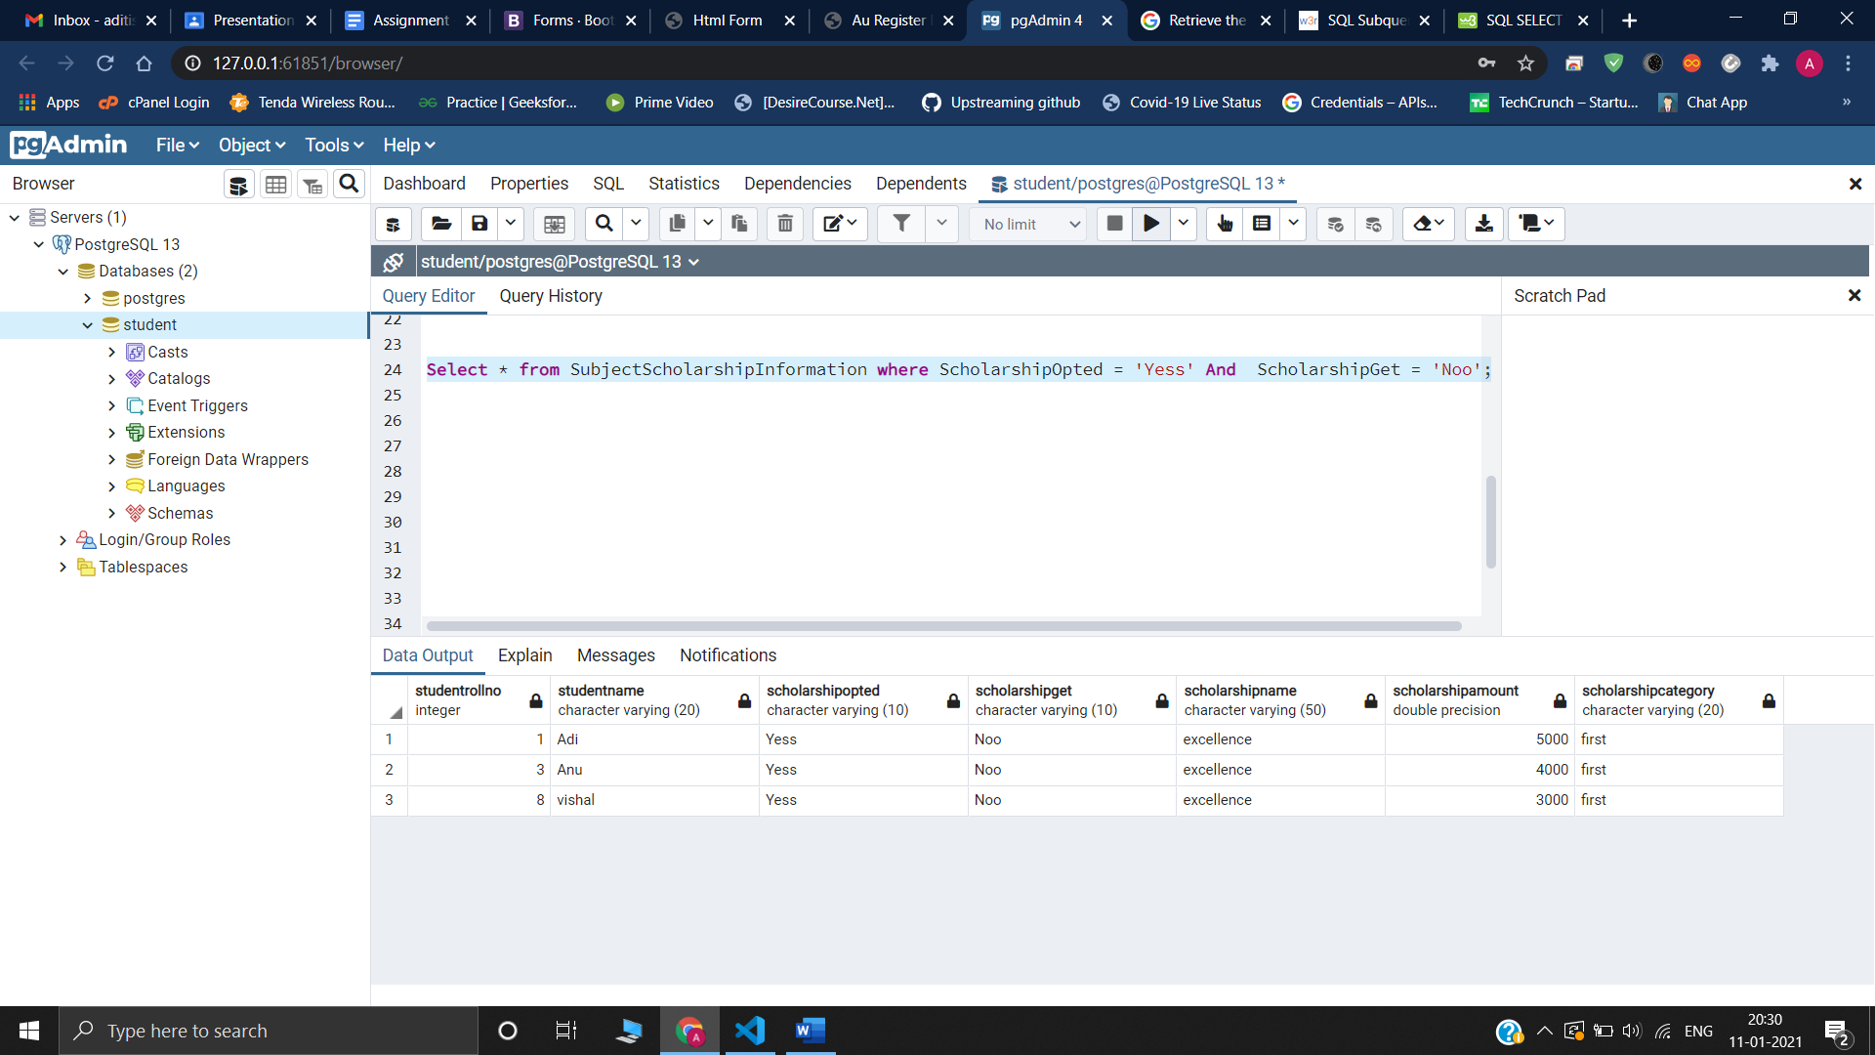

**9-**

Create or replace procedure updatepercentage(

)

Language plpgsql

As $$

Begin

Update StudentSubjectInfornation set

StudentMarksPercentage = (SubjectObtainedMarks / SubjectTotalMarks) * 100;

Commit;

End; $$

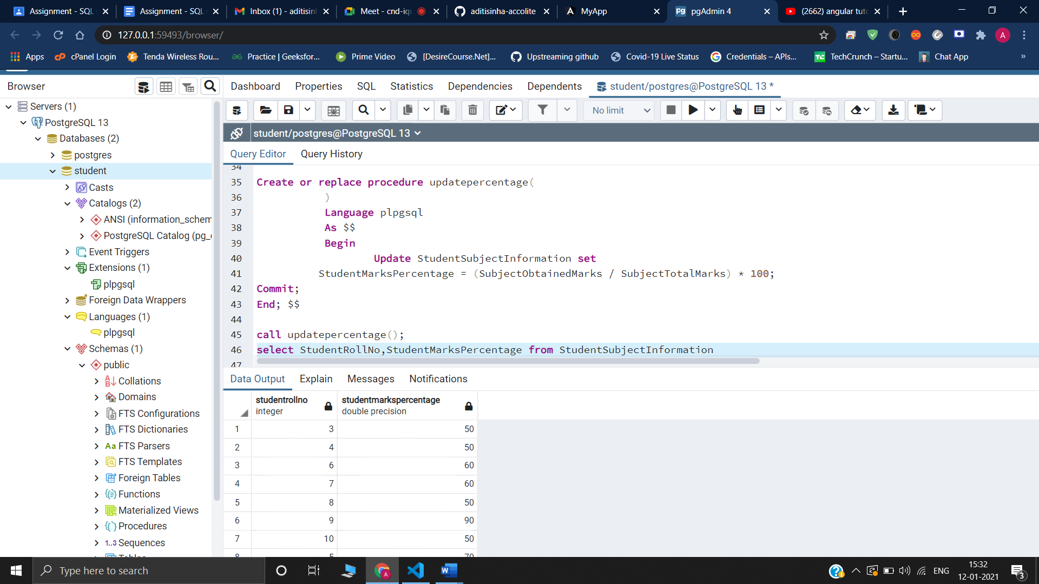

**10-**

Create or replace procedure ScholarshipCategory(

marks float,rollno int )

Language plpgsql

As $$

Begin

select StudentMarksPercentage into marks from

StudentSubjectInformation

where StudentRollNo=rollno;

if(marks>75) then

update SubjectScholarshipInformation

set ScholarshipCategory = 'first'

where StudentRollNo=rollno;

else

update SubjectScholarshipInformation

set ScholarshipCategory = 'second'

where StudentRollNo=rollno;

end if;

Commit;

End; $$

**11-**

create view showbalance AS

select S.StudentRollNo , S.StudentName ,SS.AmountBalance

FROM StudentBasicInformation S INNER JOIN StudentAdmissionPayment SS

ON S.StudentRollNo = SS.StudentRollNo;

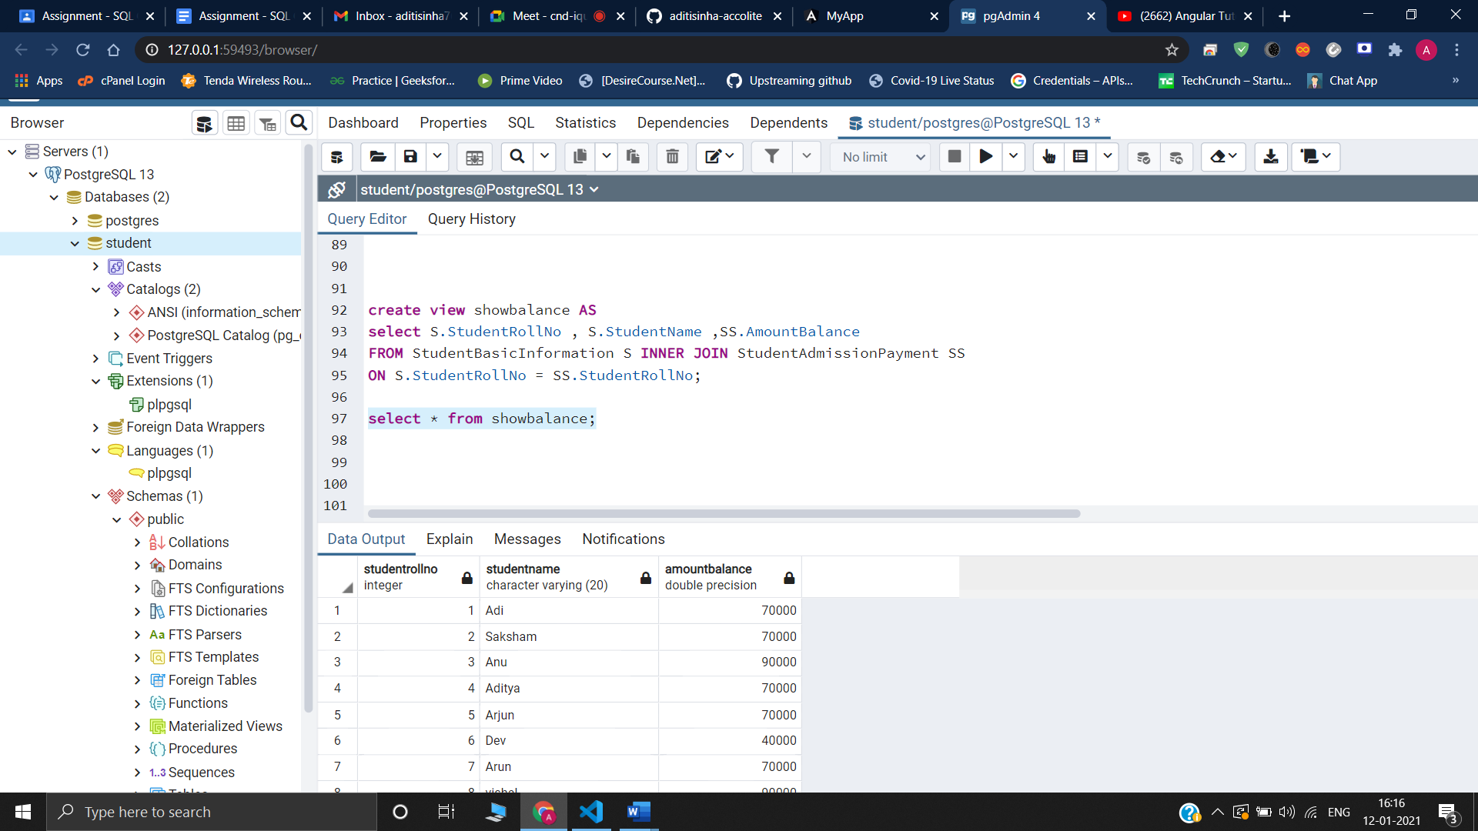

**12-**

SELECT S.StudentName ,S.StudentSurname ,S.StudentRollNo ,S.StudentId ,S.StudentCourse, S.StudentBranch ,S.StudentCity

FROM StudentBasicInformation S INNER JOIN SubjectScholarshipInformation SS

ON S.StudentRollNo = SS.StudentRollNo

WHERE ScholarshipGet = 'Noo';

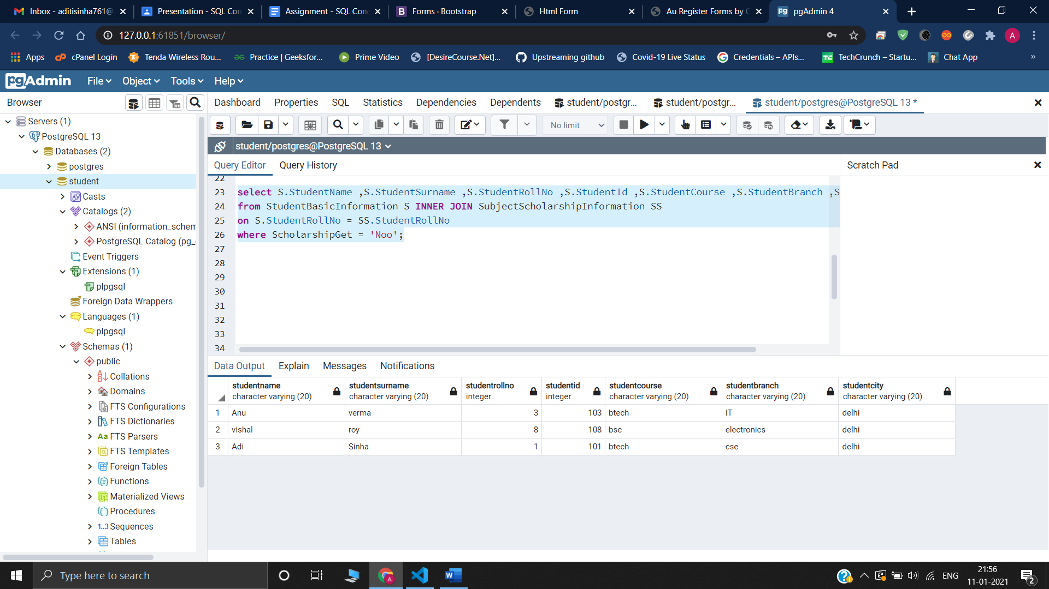

**13-**

Create or replace procedure showbalance(

inout rollno int,inout balance int )

Language plpgsql

As $$

Begin

select StudentRollNo , AmountBalance into rollno,balance from

StudentAdmissionPayment

where StudentRollNo=rollno;

RETURN;

End; $$

call showbalance(1,0);

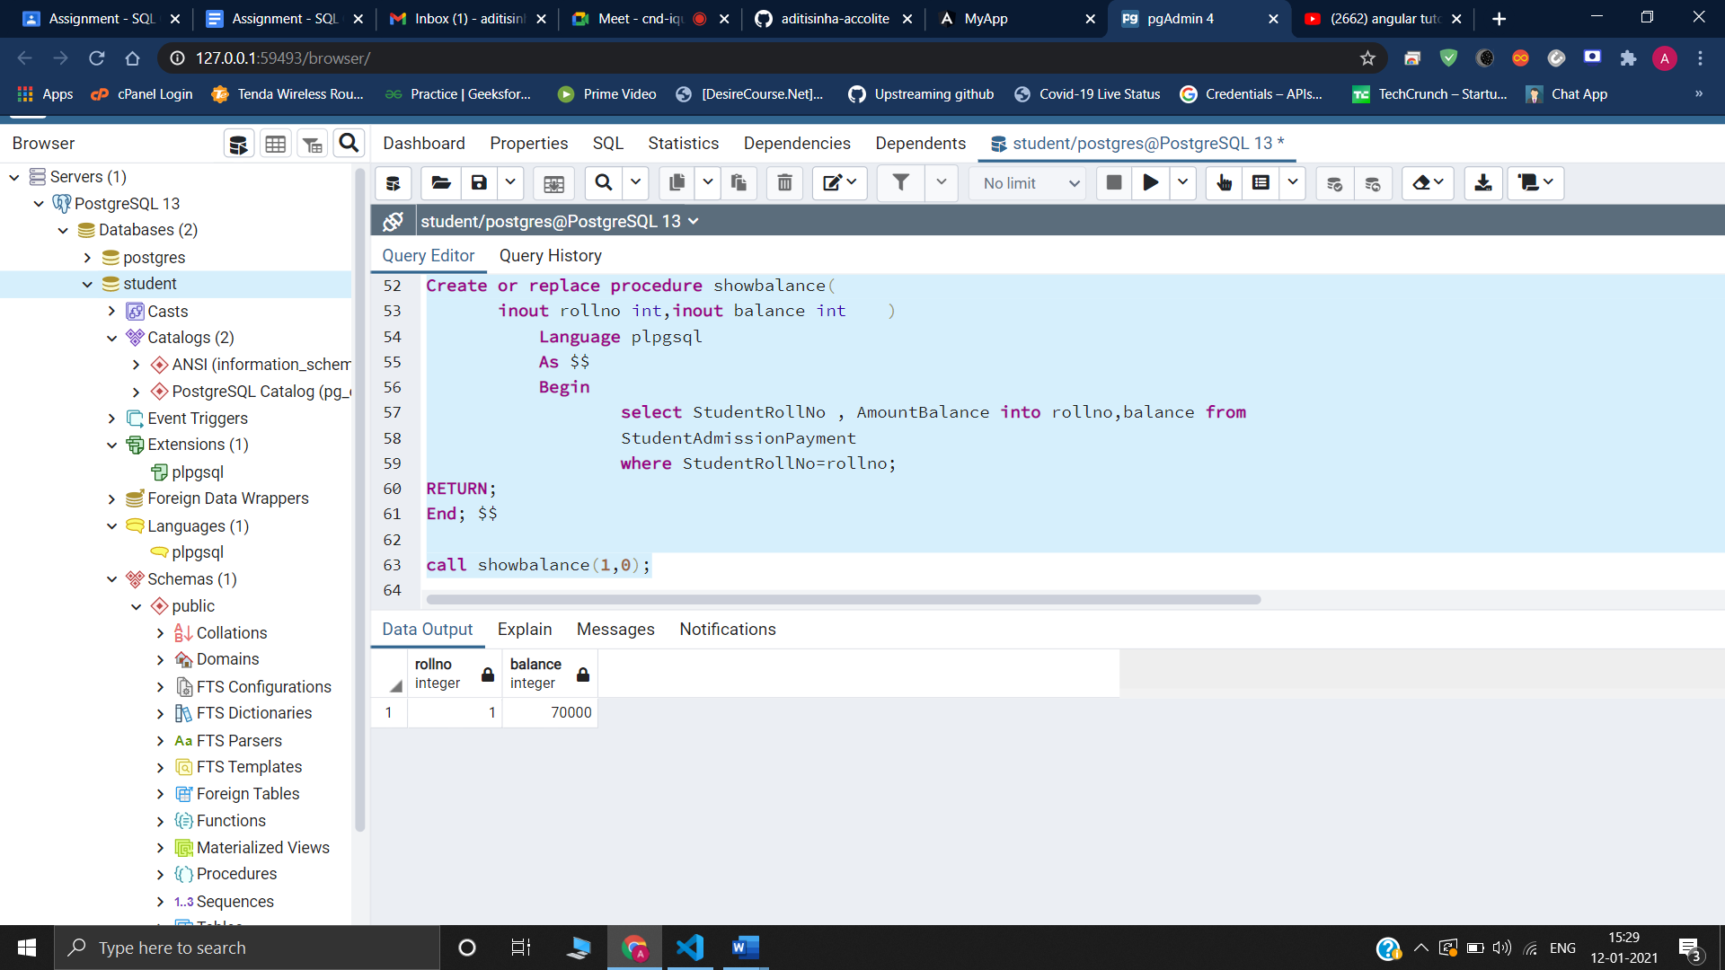

**14-**

SELECT * FROM (SELECT * FROM StudentSubjectInformation ORDER BY StudentMarksPercentage desc)

as StudentMarksPercentage

ORDER BY StudentMarksPercentage desc

limit 5;

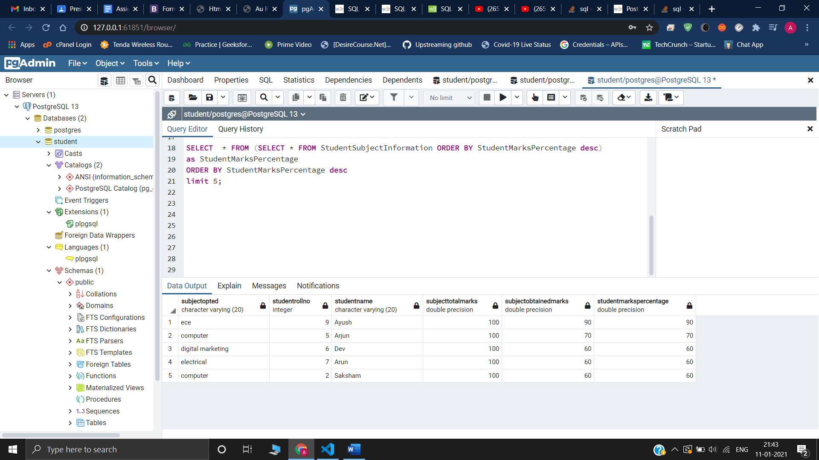

**15-**

**Inner join**

select * from StudentBasicInformation S INNER JOIN StudentSubjectInformation SS

on S.StudentRollNo = SS.StudentRollNo;

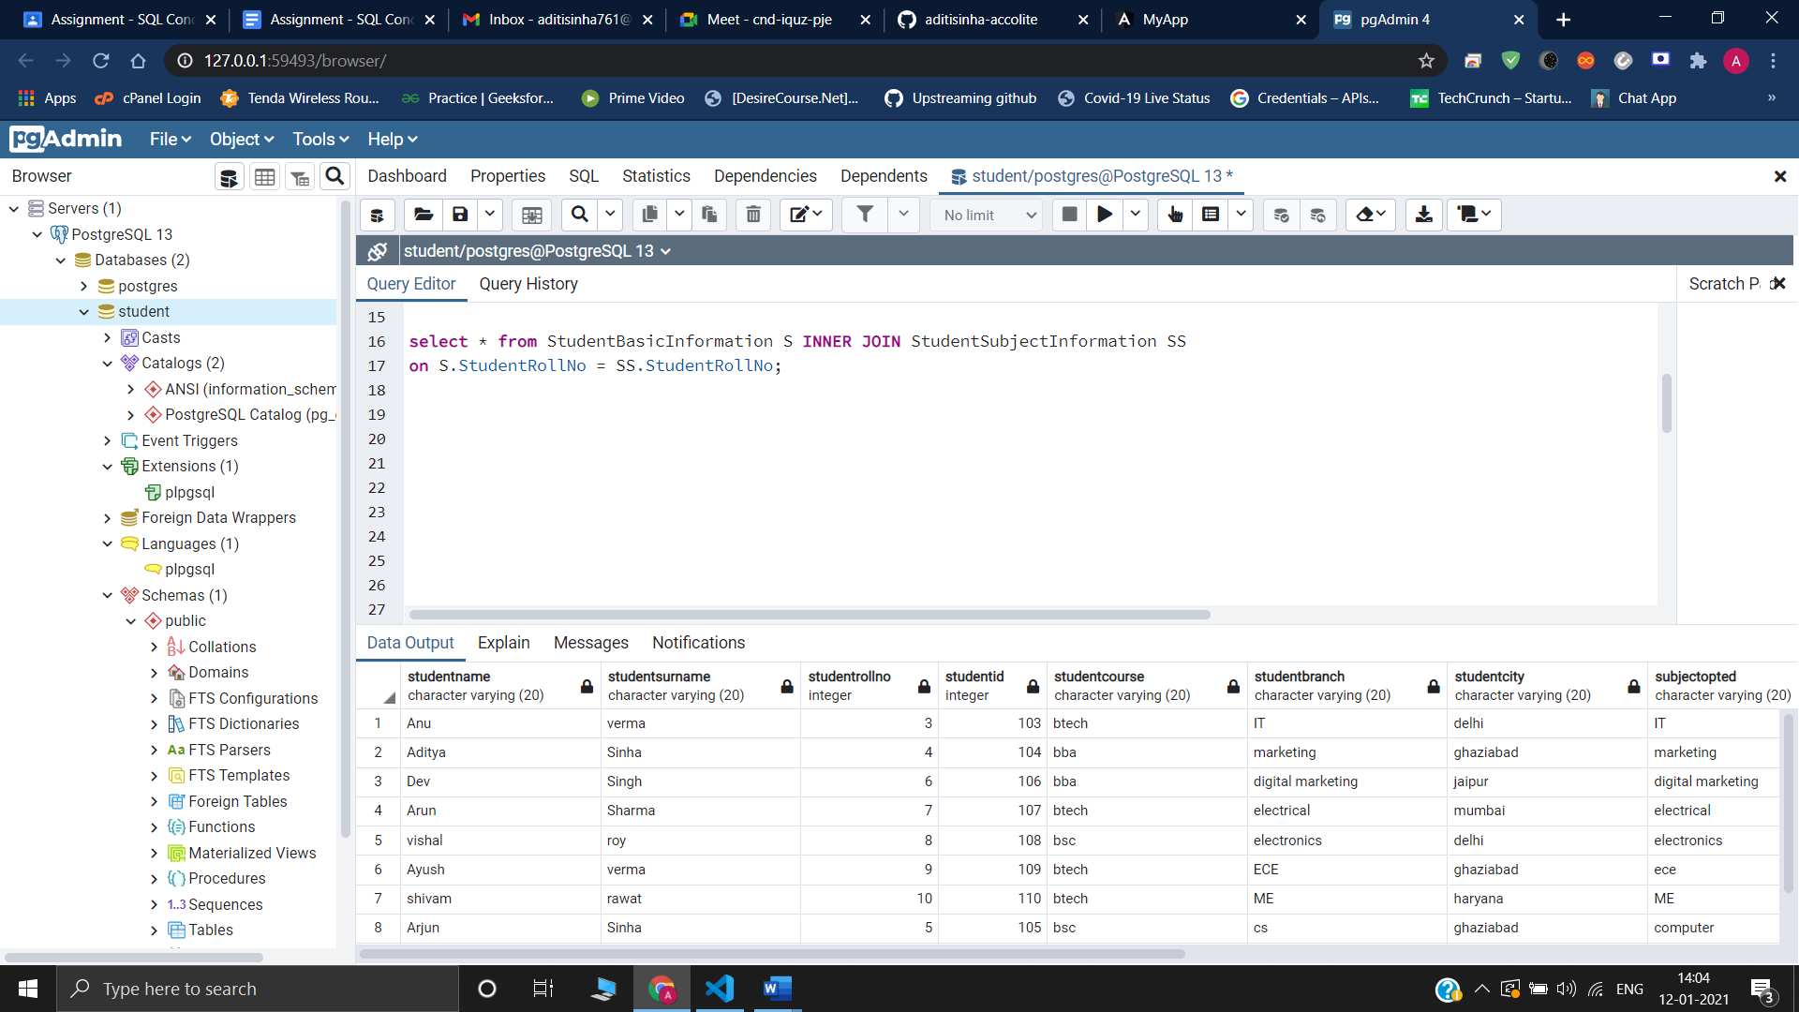

**Left join**

select * from StudentBasicInformation S LEFT JOIN StudentSubjectInformation SS

on S.StudentRollNo = SS.StudentRollNo;

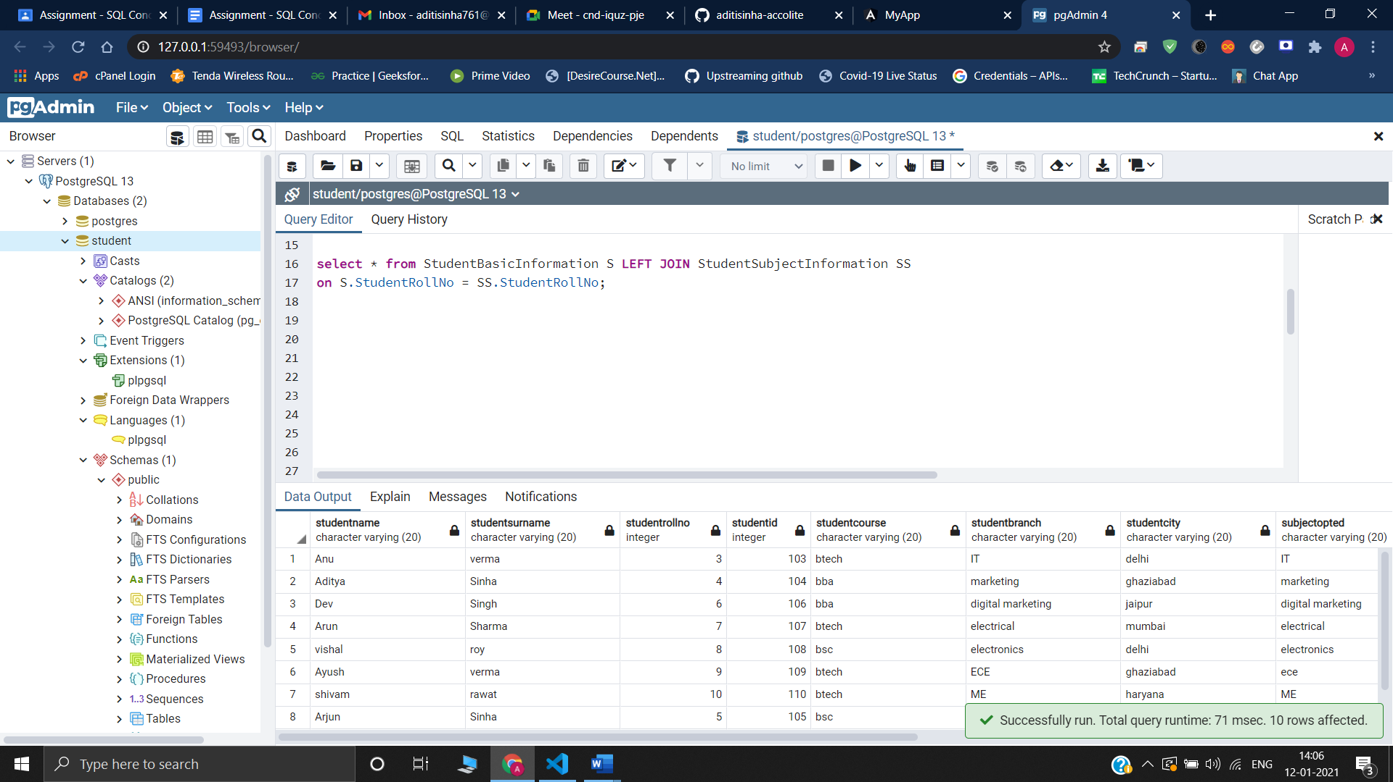

**Right join**

select * from StudentBasicInformation S RIGHT JOIN StudentSubjectInformation SS

on S.StudentRollNo = SS.StudentRollNo;

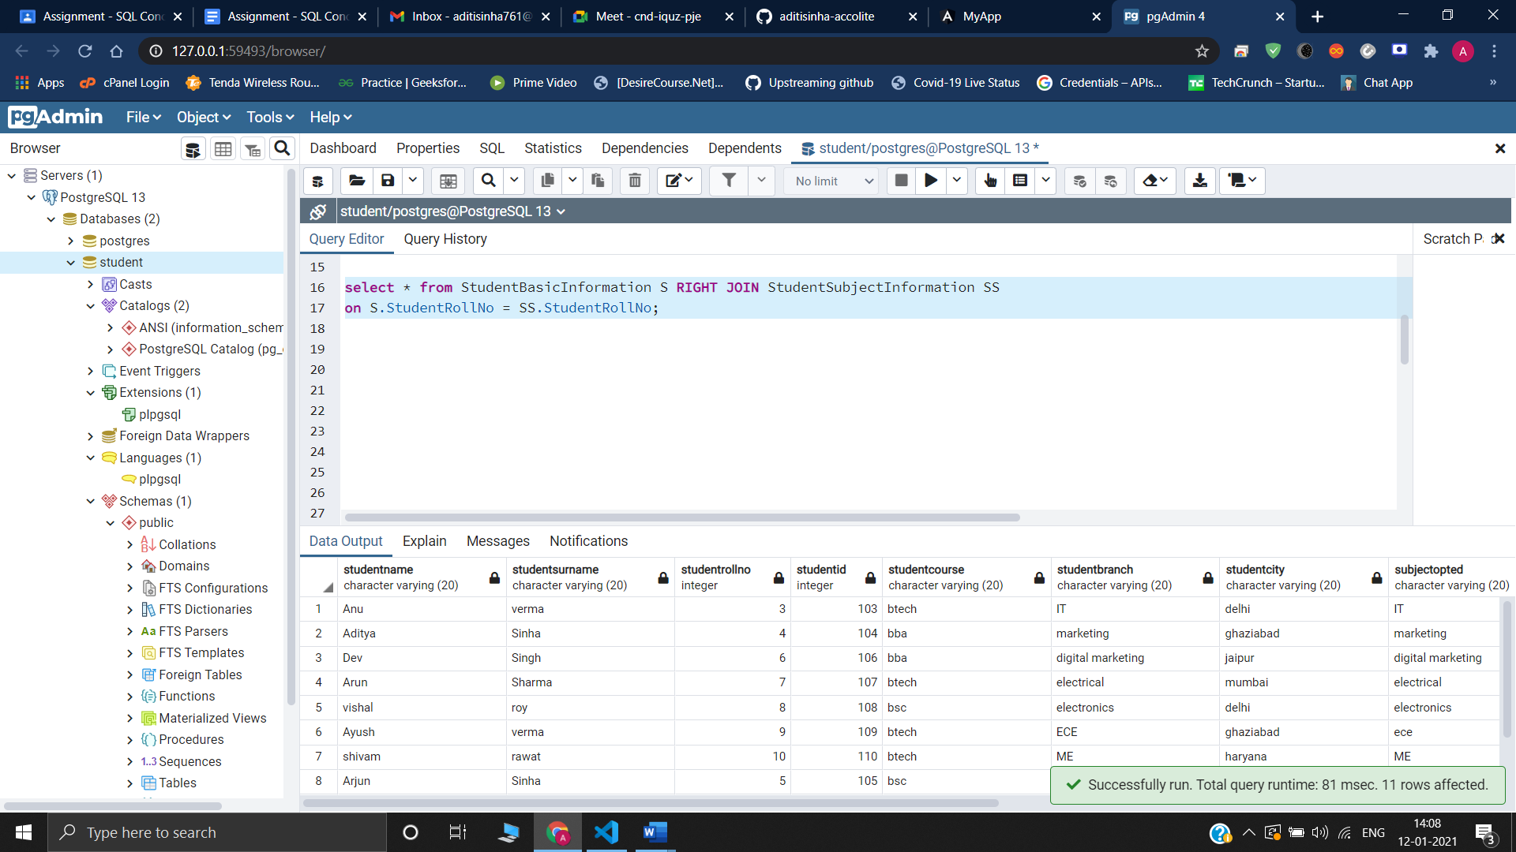

**16 –**

**Drop –** Drop is a DDL command which deletes the data of the tables as well as remove the entire schema/structure of the table from the database.

**Delete –** Delete is a DML command which delete existing records from an existing table. We can delete single or multiple records specified in the query.

**Truncate –** It is a DDL command which delete existing records from an existing table but not the table itself . we cannot use WHERE caluse and cannot specify any condition with truncate.

**17-**

select ScholarshipCategory , count(*) from

SubjectScholarshipInformation

group by ScholarshipCategory

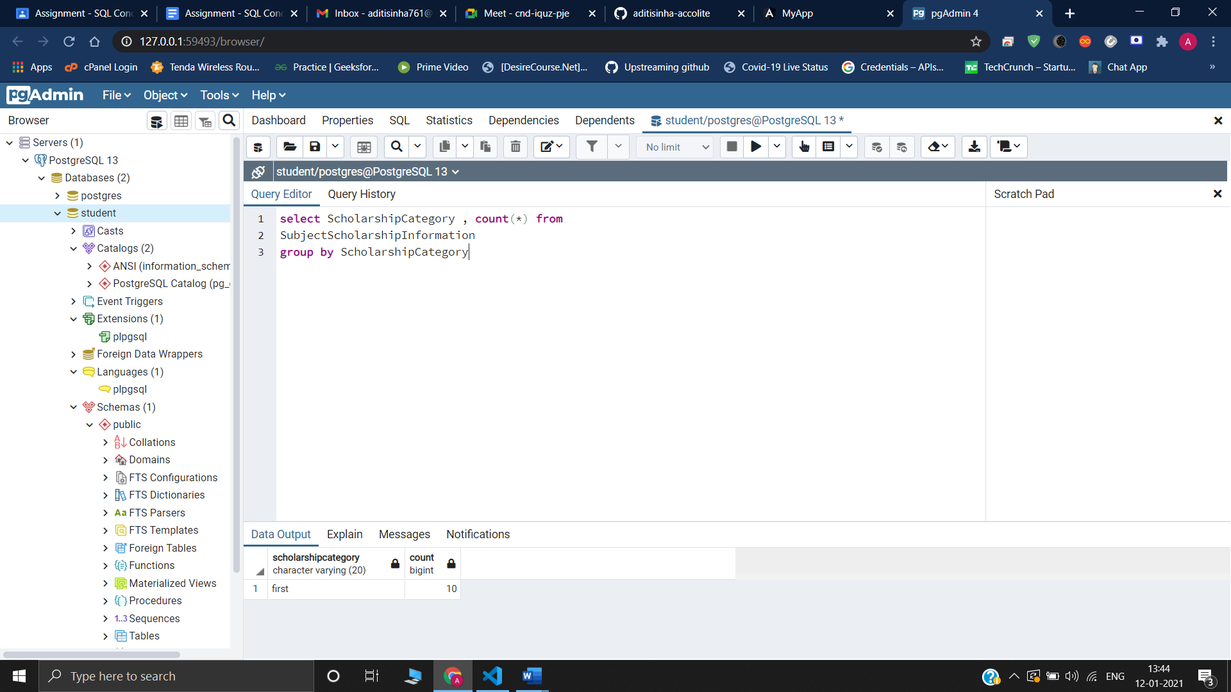

**18-**

select ScholarshipCategory , count(*) As scholarshipcategorycount

from SubjectScholarshipInformation

group by ScholarshipCategory

order by scholarshipcategorycount desc

limit 1;

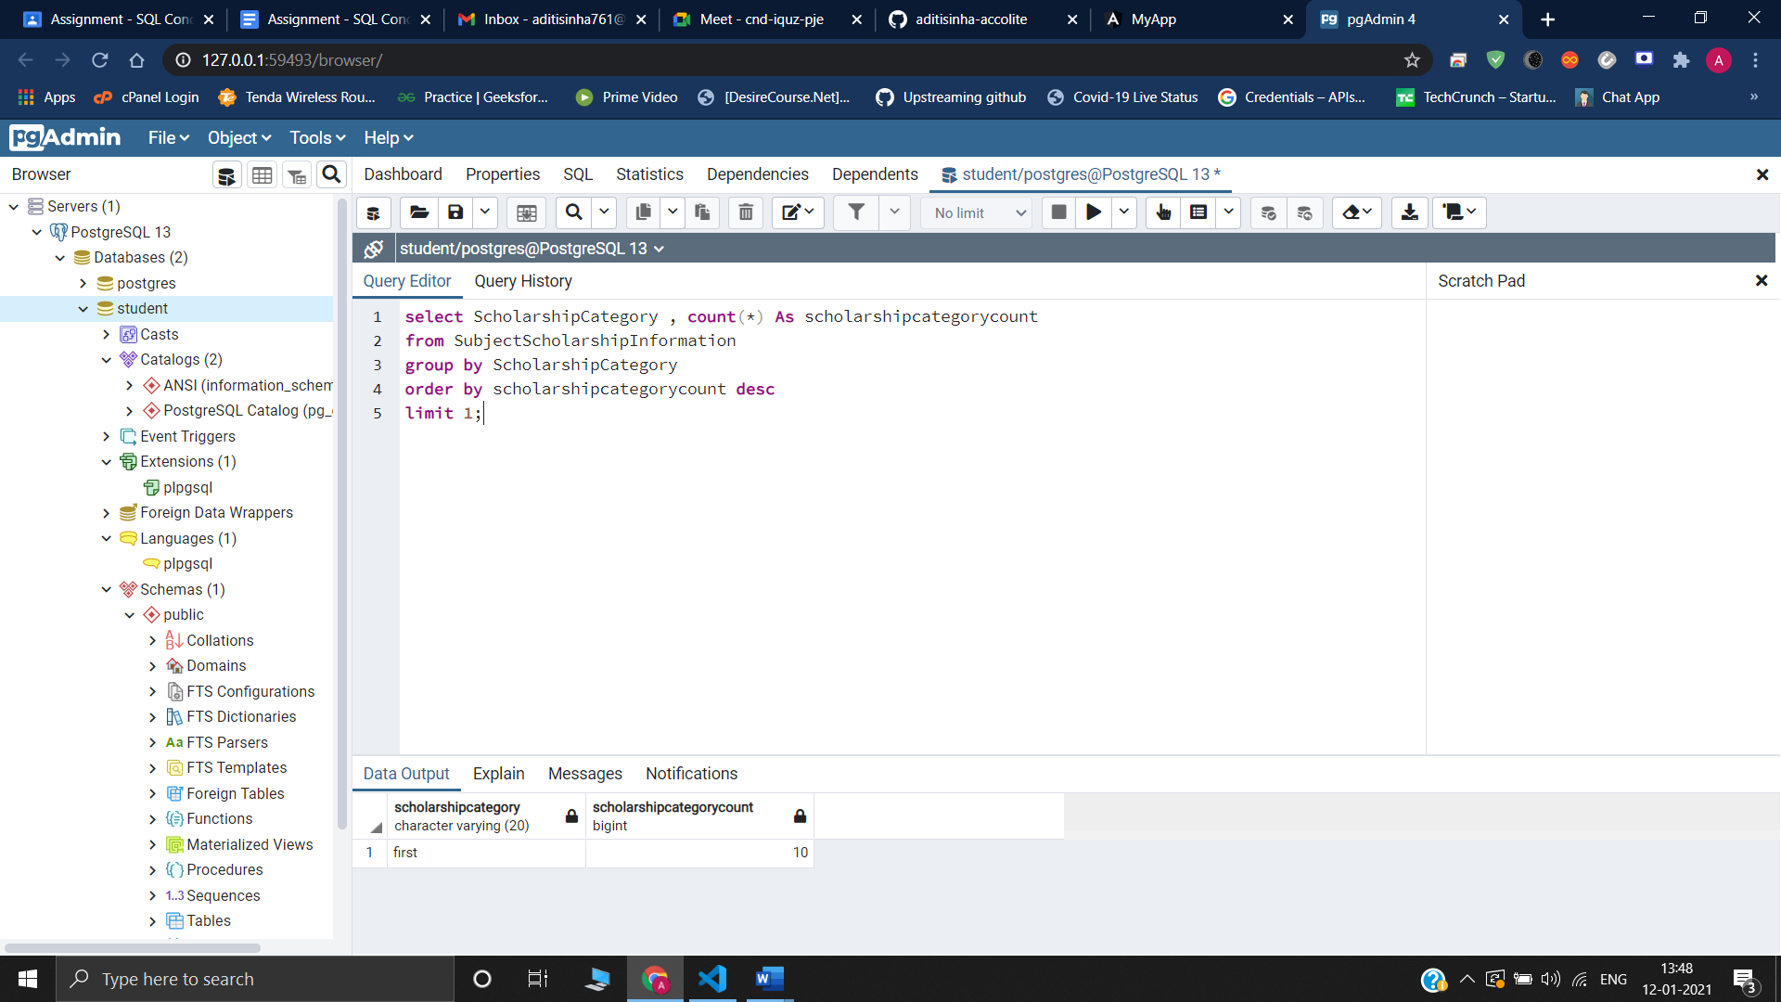

**19-**

select S.StudentName ,S.StudentRollNo,SSS.StudentMarksPercentage, SS.ScholarshipAmount from ((StudentBasicInformation S INNER JOIN SubjectScholarshipInformation SS on S.StudentRollNo = SS.StudentRollNo)

INNER JOIN StudentSubjectInformation SSS on S.StudentRollNo= SSS.StudentRollNo)

order by SSS.StudentMarksPercentage desc , SS.ScholarshipAmount desc;

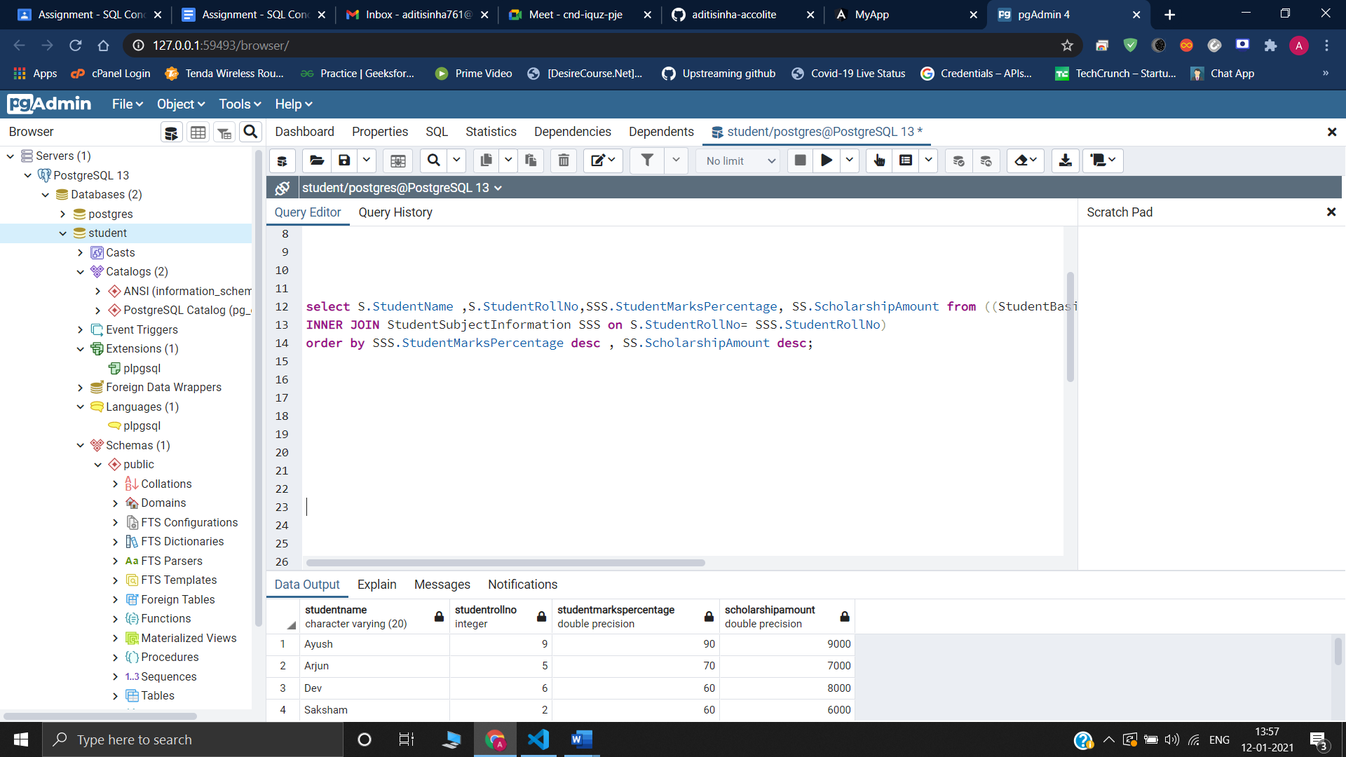

**20 –**

**Triggers -** Trigger is a stored procedure that runs automatically when various events happen (eg update, insert, delete). It can execute automatically based on the events .It can not take input as parameter .

**Stored procedures** – Stored procedures are a pieces of the code in written in SQL to do some specific task. It can be invoked explicitly by the user. It can take input as a parameter .

**Views-** View is a virtual table. It does not physically exist. Rather, it is created by a query joining one or more tables. Views returns a table.

**Function –** Function used to calculate result using given inputs and can return single value and only works with select statements